A000-ME-Syria-Tel Halaf-Fertility Idol-Headless-Terracotta-6000-5300 BCE

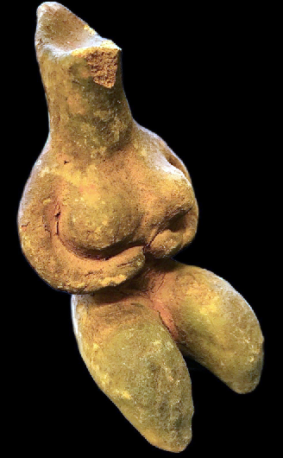

**Case no.: 2**

**Accession Number:**

**Formal Label:** Syria-Tel Halaf-Fertility Idol-Terracotta--6000-5400 BCE

**Display Description:**

**Tell Halaf** ([Arabic](https://en.wikipedia.org/wiki/Arabic_language): تل حلف‎) is an archaeological site in the [Al Hasakah](https://en.wikipedia.org/wiki/Al_Hasakah) governorate of northeastern [Syria](https://en.wikipedia.org/wiki/Syria), near the [Turkish](https://en.wikipedia.org/wiki/Turkey) border, just opposite [Ceylanpınar](https://en.wikipedia.org/wiki/Ceylanp%C4%B1nar). It was the first find of a [Neolithic](https://en.wikipedia.org/wiki/Neolithic) culture, subsequently dubbed the [Halaf culture](https://en.wikipedia.org/wiki/Halaf_culture), characterized by glazed pottery painted with geometric and animal designs. The site, which dates to the 6th millennium BCE, was a [Hittite](https://en.wikipedia.org/wiki/Hittites) ruling city at first and was later the location of the [Aramaean](https://en.wikipedia.org/wiki/Aramaean) city-state of **Guzana** or Gozan in the 10th century BCE. By the end of 9th century BCE the city and its surrounding area was incorporated into the [Assyrian Empire](https://en.wikipedia.org/wiki/Assyrian_Empire).

The **Halaf culture** is a [prehistoric](https://en.wikipedia.org/wiki/Prehistoric) period which lasted between about 6100 BCE and 5100 BCE.[[1]](https://en.wikipedia.org/wiki/Halaf_culture#cite_note-mario-1) The period is a continuous development out of the earlier [Pottery Neolithic](https://en.wikipedia.org/wiki/Neolithic#Neolithic_3_.E2.80.93_Pottery_Neolithic_.28PN.29) and is located primarily in south-eastern [Turkey](https://en.wikipedia.org/wiki/Turkey), [Syria](https://en.wikipedia.org/wiki/Syria), and northern [Iraq](https://en.wikipedia.org/wiki/Iraq), although Halaf-influenced material is found throughout Greater [Mesopotamia](https://en.wikipedia.org/wiki/Mesopotamia).

While the period is named after the site of [Tell Halaf](https://en.wikipedia.org/wiki/Tell_Halaf) in north [Syria](https://en.wikipedia.org/wiki/Syria), excavated by [Max von Oppenheim](https://en.wikipedia.org/wiki/Max_von_Oppenheim) between 1911 and 1927, the earliest Halaf period material was excavated by [John Garstang](https://en.wikipedia.org/wiki/John_Garstang) in 1908 at the site of [Sakce Gözü](https://en.wikipedia.org/wiki/Sakce_G%C3%B6z%C3%BC), then in Syria but now part of Turkey.[[2]](https://en.wikipedia.org/wiki/Halaf_culture#cite_note-2) Small amounts of Halaf material were also excavated in 1913 by [Leonard Woolley](https://en.wikipedia.org/wiki/Leonard_Woolley) at Carchemish, on the Turkish/Syrian border.[[3]](https://en.wikipedia.org/wiki/Halaf_culture#cite_note-3) However, the most important site for the Halaf tradition was the site of [Tell Arpachiyah](https://en.wikipedia.org/wiki/Tell_Arpachiyah), now located in the suburbs of [Mosul](https://en.wikipedia.org/wiki/Mosul), [Iraq](https://en.wikipedia.org/wiki/Iraq).[[4]](https://en.wikipedia.org/wiki/Halaf_culture#cite_note-4)

The Halaf period was succeeded by the [Halaf-Ubaid Transitional period](https://en.wikipedia.org/wiki/Halaf-Ubaid_Transitional_period) which comprised the late Halaf (c. 5400-5000 BC), and then by the [Ubaid period](https://en.wikipedia.org/wiki/Ubaid_period).

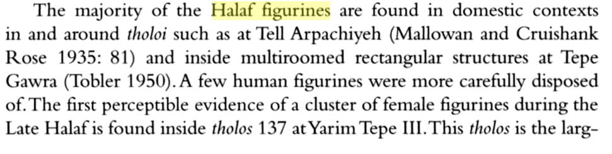

**LC Classification: DS39.T38**

**Date or Time Horizon:** 6000-5400 BCE

**Geographical Area:** Northern Syria

**Map:**

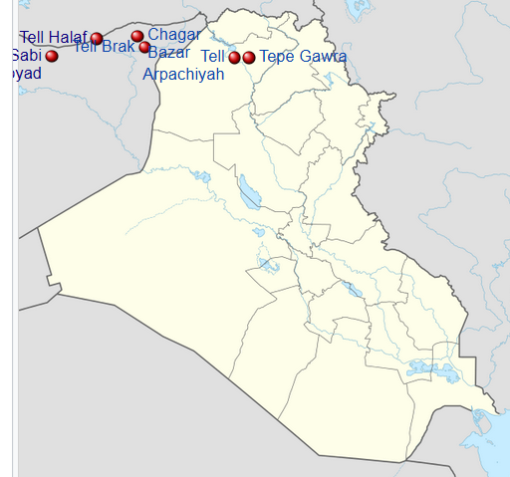

Map of [Iraq](https://en.wikipedia.org/wiki/Iraq) showing important sites that were occupied during the Halaf culture **. After https://upload.wikimedia.org/wikipedia/commons/thumb/8/80/Iraq_adm_location_map.svg/600px-Iraq_adm_location_map.svg.png**

[Tell Halaf](https://en.wikipedia.org/wiki/Tell_Halaf)



[Tell Brak](https://en.wikipedia.org/wiki/Tell_Brak)



[Tell Sabi Abyad](https://en.wikipedia.org/wiki/Tell_Sabi_Abyad)



[Tell Arpachiyah](https://en.wikipedia.org/wiki/Tell_Arpachiyah)



[Tepe Gawra](https://en.wikipedia.org/wiki/Tepe_Gawra)



[Chagar Bazar](https://en.wikipedia.org/wiki/Chagar_Bazar)

**GPS coordinates:** [36.8266°N 40.0396°E](https://tools.wmflabs.org/geohack/geohack.php?pagename=Tell_Halaf&params=36.8266_N_40.0396_E_type:landmark)

**Cultural Affiliation:**

**Medium:** terracotta

**Dimensions:**

**Weight:**

**Condition:**

**Provenance:**

**Discussion:**

The Halaf culture diffused in northern Syria in the Jezirah steppe east of the Euphrates that was laced by the Balikh perennial river that created a basin characterized by highly diffuse channels that provided abundant water for vegetation in the midst of the steppe. Here people first settled 11,000 years ago. Hundreds of previously unknown archaeological sites have been identified

**Tell Halaf** ([Arabic](https://en.wikipedia.org/wiki/Arabic_language): تل حلف‎) is a Neolithic archaeological site in northeastern Syria, which dates to 6000-5300 BCE. It is characterized by a distinctive glazed pottery with geometric and animal designs.

An earlier Neolithic complex in northern Syria at Tell Sabi Abyad comprised four prehistoric sites that were occupied back and forth between c 7500 BCE and 5500 BCE. They contain the earliest pottery of Syria dating to 6900-6800 BCE which is mineral-tempered and painted. = Sabi Abyad has 11 occupational levels in which 11 to 7 are *pre-Halaf*; 6 to 4 are transitional; and 3 to 1 are *early Halaf* (Masetti-Rouault, Rouault and Wafler 2000: 43–44).

This continuity of Tell Sabi Abyad and Tell Halaf demonstrates that the Halaf culture diffused gradually as an indigenous culture in northern Syria (Akkermans and Schwartz 2003: 116) that spread from Sabi Abyad to the other regions (Liverani 2013: 48).



Area of the diffusion of the Halaf Culture after https://upload.wikimedia.org/wikipedia/commons/2/24/Kultura_Halaf_zasieg.jpg

**References:**

Akkermans, P.M. 2000. Old and new perspectives on the origins of the Halaf culture. In Masetti-Rouault, Maria Grazia, Olivier Rouault and M. Wafler, eds., *La Djéziré et l’Euphrate syriens de la protohistoire à la fin du IIe milléaire AV. J.-C. Subartu*, *7*, pp. 43-54.

Akkermans, Peter M. M. G. and Glenn M. Schwartz. 2003. The Archaeology of Syria: From Complex Hunter-Gatherers to Early Urban Societies (c.16,000-300 BC). Cambridge: Cambridge University Press.

Brooke, John L. 2014. *Climate change and the course of global history: a rough journey*. Cambridge: Cambridge University Press.

Campbell, S. 2000. "The Burnt House at Arpachiyah: A Reexamination," *Bulletin of the American Schools of Oriental Research,* no. 318

Gessner, Castro. 2011. "A Brief Overview of the Halaf Tradition" in Steadman, S and McMahon, G (eds.) *The Oxford Handbook of Ancient Anatolia*. Oxford: Oxford University Press.

Liverani, Mario. 2013. The Ancient Near East: History, Society and Economy. London: Routledge.

Pollock, Susan and Reinhard Bernbeck, eds. 2009. Archaeologies of the Middle East: critical perspectives. John Wiley & Sons.

Roux. Georges.1992. Ancient Iraq. London: Penguin UK.

Speakman, Robert J. and Hector Neff. 2005. Laser Ablation ICP-MS in Archaeological Research. Albuquerque [N.M.]: University of New Mexico Press.